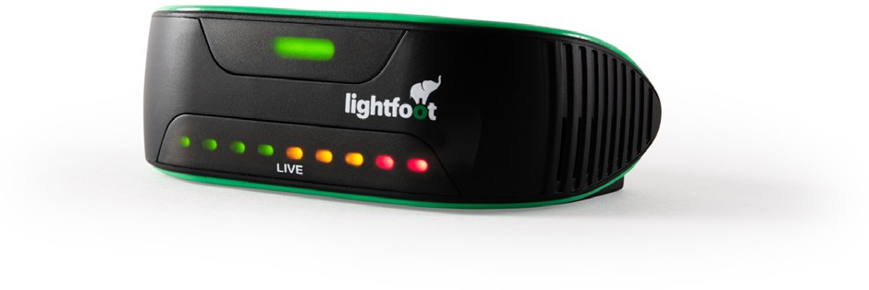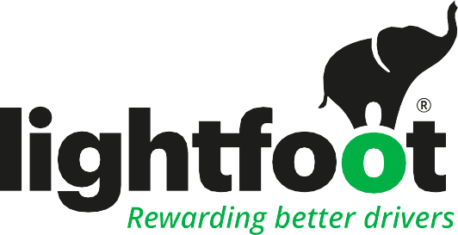

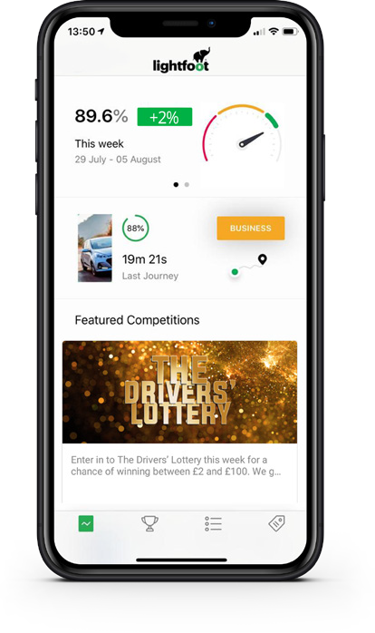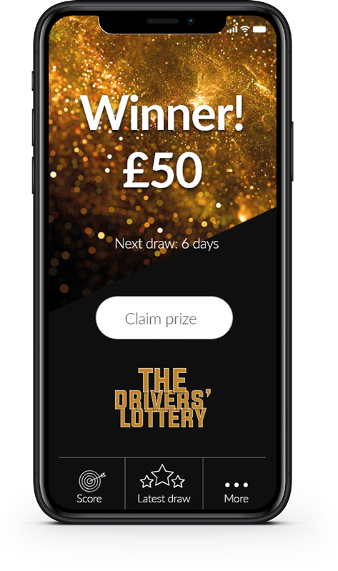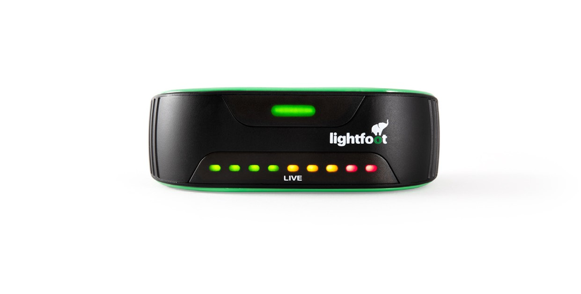

COMING SOON

to a vehicle near you

Dear colleagues,

In the next few months we will be introducing a new system called Lightfoot across all vehicles

in our fleet.

We have made the decision to roll out Lightfoot after running a successful trial of the product

which saw improved driving with more ‘Elite’ drivers and no accidents.

Lightfoot is an innovative driver coaching technology and rewards platform designed to help

you stay safe, save fuel and reduce the environmental impact of your vehicle.

We have chosen Lightfoot because it is a pro-driver system providing guidance in-vehicle

helping to reduce risk and increase fuel efficiency.

Lightfoot is not like traditional telematics. It gives you the power and tools to enhance your driving but also rewards you with some great personal benefits.

Benefits of Lightfoot:

•

Opportunities to win prizes using your Lightfoot score in weekly prize draws

Gives you an app to check your own performance

Entry to the Drivers’ Lottery for all elite drivers with the chance to win cash prizes every week

•

•

We’ll be in contact again soon to provide more information on the system as well as how and when we will be rolling the technology out.

Long term performance indicators

Real-time Audio feedback

Real-time “LIVE “ performance indicators